Russian Federation: Asian Development Outlook

# GDP growth in 2019

1. Overall GDP growth: GDP growth slowed down from 2.5% in 2018 to 1.3% in 2019.
2. Main sources of growth: On the demand side, private consumption contributed the most with 1.3 percentage points (pp), followed by gross capital formation (0.8pp) and government expenditure (0.4pp). On the production side, services and industry (including construction) contributed 0.9pp and 0.8pp to overall growth, respectively.
3. Other sources of growth: On the other hand, net exports had a negative contribution to growth at 1.4pp. Meanwhile, agriculture contributed 0.pp.

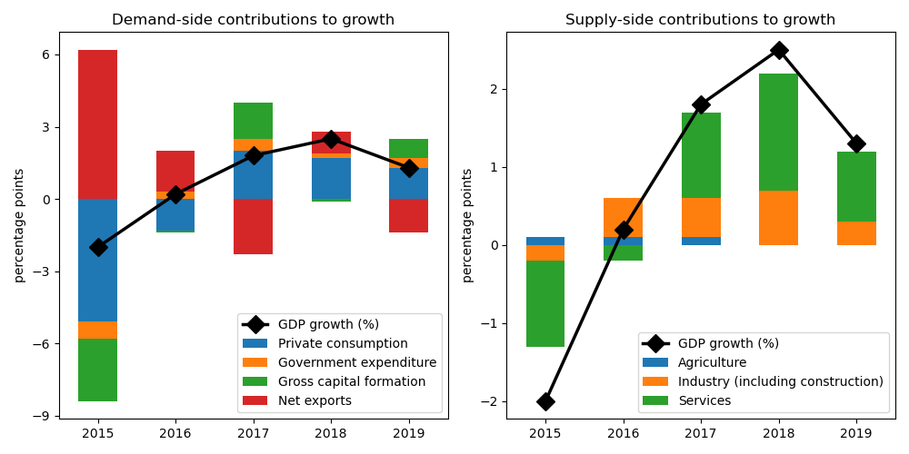

# Expenditure approach

1. Private consumption: Private consumption growth decreased from 3.3% in 2018 to 2.5% in 2019, accounting for 50.4% of GDP.
2. Government expenditure: Government expenditure growth increased from 1.3% in 2018 to 2.2% in 2019, accounting for 18.3% of GDP.
3. Gross capital formation: Gross capital formation growth increased from -0.6% in 2018 to 3.8% in 2019, accounting for 23.1% of GDP.
4. Net exports: Net exports growth slowed down from 97.9% in 2018 to -22.3% in 2019, accounting for 7.6% of GDP.

# Production approach

1. Agriculture: Agriculture growth slowed down from 0.9% in 2018 to 0.6% in 2019, accounting for 3.4% of GDP.
2. Industry (including construction): Industry (including construction) growth decreased from 2.2% in 2018 to 1.0% in 2019, accounting for 32.2% of GDP.
3. Services: Services growth contracted from 2.7% in 2018 to 1.6% in 2019, accounting for 54.0% of GDP.

# Income approach

1. Employment: Unemployment rate slowed down from 4.8% in 2018 to 4.5% in 2019.

# Inflation

1. Inflation: Inflation rate jumped from 2.9% in 2018 to 4.5% in 2019.

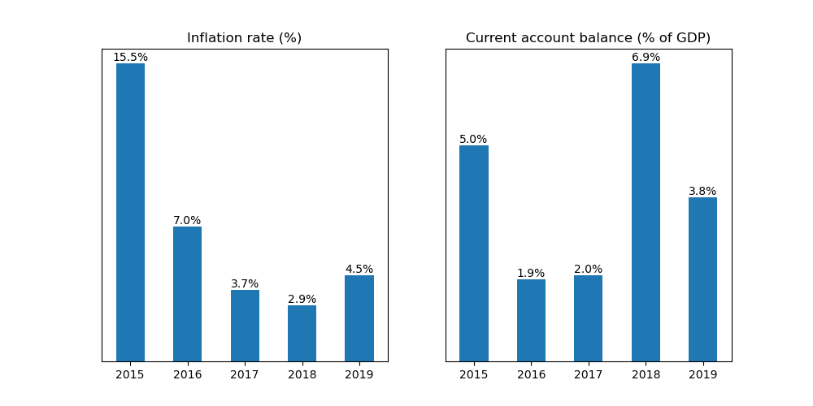

# Current Account Balance

1. Current account balance (CAB): CAB recorded a surplus at 3.8% of GDP in 2019. Net trade in goods and services reached USD 129.0 billion. In 2018, CAB posted a surplus at 6.9% of GDP.
2. Top exports partners: Top exports destinations in 2019 are China (13.4% of total exports), Netherlands (10.5%), Germany (6.6%), Belarus (5.1%), and Turkey (5.0%).
3. Top export commodities: Top export commodities include mineral fuels, mineral oils and products of their distillation; bituminous substances; mineral waxes (52.0% of total exports), commodities not specified according to kind (13.0%), iron and steel (4.3%), natural, cultured pearls; precious, semi-precious stones; precious metals, metals clad with precious metal, and articles thereof; imitation jewellery; coin (3.6%), and nuclear reactors, boilers, machinery and mechanical appliances; parts thereof (2.1%).
4. Top imports partners: Top imports origins in 2019 are China (21.9% of total imports), Germany (10.2%), Belarus (5.5%), USA (5.4%), and Italy (4.4%).
5. Top import commodities include nuclear reactors, boilers, machinery and mechanical appliances; parts thereof (17.5% of total imports), electrical machinery and equipment and parts thereof; sound recorders and reproducers; television image and sound recorders and reproducers, parts and accessories of such articles (12.1%), vehicles; other than railway or tramway rolling stock, and parts and accessories thereof (9.7%), pharmaceutical products (5.7%), and plastics and articles thereof (4.0%).

# Outlook

1. Consumer confidence: Consumer confidence index contracted to -22.0 points in Q3 of 2020 from -13.0 points in the same quarter in the previous year, reflecting more pessimistic consumer sentiments. Consumer expectations about the general economic situation in the next 12 months worsened to -15.0 points from -9.0 points, indicating negative expections about the country's current and future economic situation.
2. Industrial production: Indutrial output improved to -4.9% year-on-year in August this year from -5.4% in the previous month. Looking at the details, manufacturing declined to -3.8% from -3.2%, while mining and quarrying improved to -12.0% from -15.1%. Meanwhile, water supply, sewerage, waste management & remediation improved to -6.9% from -7.3%, while electricity, gas, steam and air conditioning supply declined to -3.3% from -2.5%.
3. Inflation: Inflation worsened to 4.0% year-on-year in October this year from 3.7% in the previous month. Prices for food products worsened to 4.8% from 4.3%, while housing, rent, water, electricity, gas & other fuels worsened to 3.4% from 3.3%. Transportation declined to -0.1% from 0.5%, while communication improved to 4.3% from 5.2%. Meanwhile, prices for health/medical care worsened to 4.2% from 4.1%, recreation jumped to 2.3% from 2.0%, and education declined to 1.9% from 2.1%
4. Monetary policy: Russian Federation's central bank maintained the key interest rate at 4.25% in October from 4.25% in September.
5. Comments on current events
6. Outlook: On November 6, 2020, Consensus Economics panelists forecast Russian Federation' economic growth ending in 2020 at -4.0%. In 2021, the panelists project growth to end the year at 2.9%.
7. Risks